**DAILY ONLINE ACTIVITIES SUMMARY**

|  |  |  |  |  |  |  |  |  |
| --- | --- | --- | --- | --- | --- | --- | --- | --- |
| **Date:** | **03/07/2020** | | | | | **Name:** | **NIKHIL KUMAR** | |
| **Sem & Sec** | **4thSEM. & ‘B’ SEC.** | | | | | **USN:** | **4AL19CS400** | |
| **Online Test Summary** | | | | | | | | |
| **Subject** | | **NULL** | | | | | | |
| **Max. Marks** | | **30** | | **Score** | | |  | |
| **Certification Course Summary** | | | | | | | | |
| **Course** | **Built your own chatbot** | | | | | | | |
| **Certificate Provider** | | | **Cognitiveclass** | | **Duration** | | | **1 week** |
| **Coding Challenges** | | | | | | | | |
| **Problem Statement1 :** | | | | | | | | |
| **Status:** | | | | | | | | |
| **Uploaded the report in Github** | | | | | **Yes** | | | |
| **If yes Repository name** | | | | | **1** | | | |
| **Uploaded the report in slack** | | | | | **Yes** | | | |

**Online Test Summary : Not conducted**

**Certification Course Summary: Today went through the module3:working with entity which includes “ understanding entities, lab4, lab5 including quiz”**

**Snapshot is given below 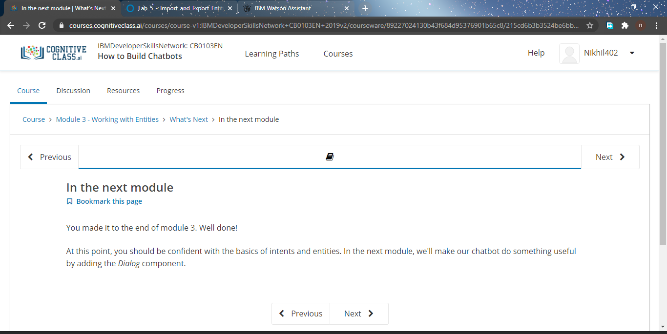Online Training : Today I had attended the online training organized by CSE Department AIET. The training was on “ Loops, decision making statements and some basic c program“done by prof. Megha hegde CSE Dept. After the session the quiz was conducted.**

**Snapshot is given below :**

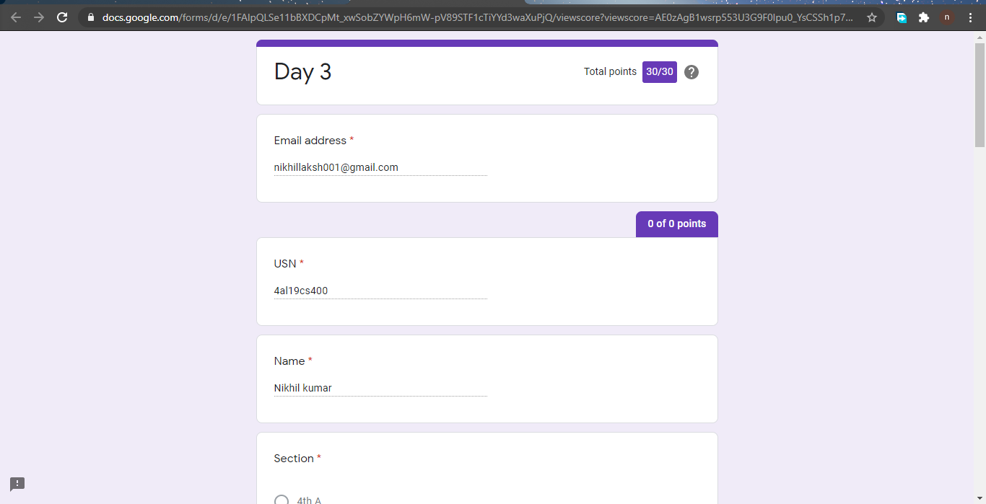

**Online coding summary: NULL.**

**Thank you.**